Project 6-1: Creating and Using QR Codes
Estimated Time: 25 minutes
Objective: Demonstrate the risks of using QR codes.
Description: Quick Response (QR) codes can be read by an imaging device such as a mobile device’s camera or online. However, they pose a security risk. In this project, you create and use QR codes.
- Use your web browser to go to www.qrstuff.com. (If you are no longer able to access the program through this URL, use a search engine to search for “Qrstuff”.)
- First, create a QR code. Under DATA TYPE, select Website URL is selected.
- Under CODE CONTENT, enter the URL http://www.cengage.com. Watch how the QR CODE PREVIEW changes as you type.
- Click Next until the TRACKING & ANALYSIS page opens.
- Under Encoding Options, select Static - Embed URL into code as is.
- Click the Download button to download an image of the QR code.
- Navigate to the location of the download and open the image. Is there anything you can tell by looking at this code? How could a threat actor use this to his advantage? Where could malicious QR codes be used? Is there any protection for the user when using QR codes?
No there is nothing you can tell by looking at the qr code. A threat actor can use this to his advantage by stuffing whatever malicious content they want in a qr code since its not readable by humans. Malicious qr code can be used on physical items or on websites where it directs you to downloading an app if you scan it. There is not a whole lot of protection for users but you could use an online qr code scanner to see if the contents of the qr code is malicious.

- Now use an online reader to interpret the QR code. Use your web browser to go to blog.qr4.nl/Online-QR-Code-Decoder.aspx (The location of content on the Internet may change without warning. If you are no longer able to access the program through this URL, use a search engine and search for “Free Online QR Code Reader”).
- Click Choose File.
- Navigate to the location of the QR code that you downloaded on your computer and click Open.
- Click Upload.
- In the text box, what is displayed? How could an attacker use a QR code to direct a victim to a malicious website?
The text box displays the website I stuffed into the qr code http://www.cengage.com. They can either put it on a piece of merchandise that looks like its directing to the company’s website but it’s actually the malicious site or they could put it somewhere on a webpage and have it look like it directs to an official site or app but it directs to malware.
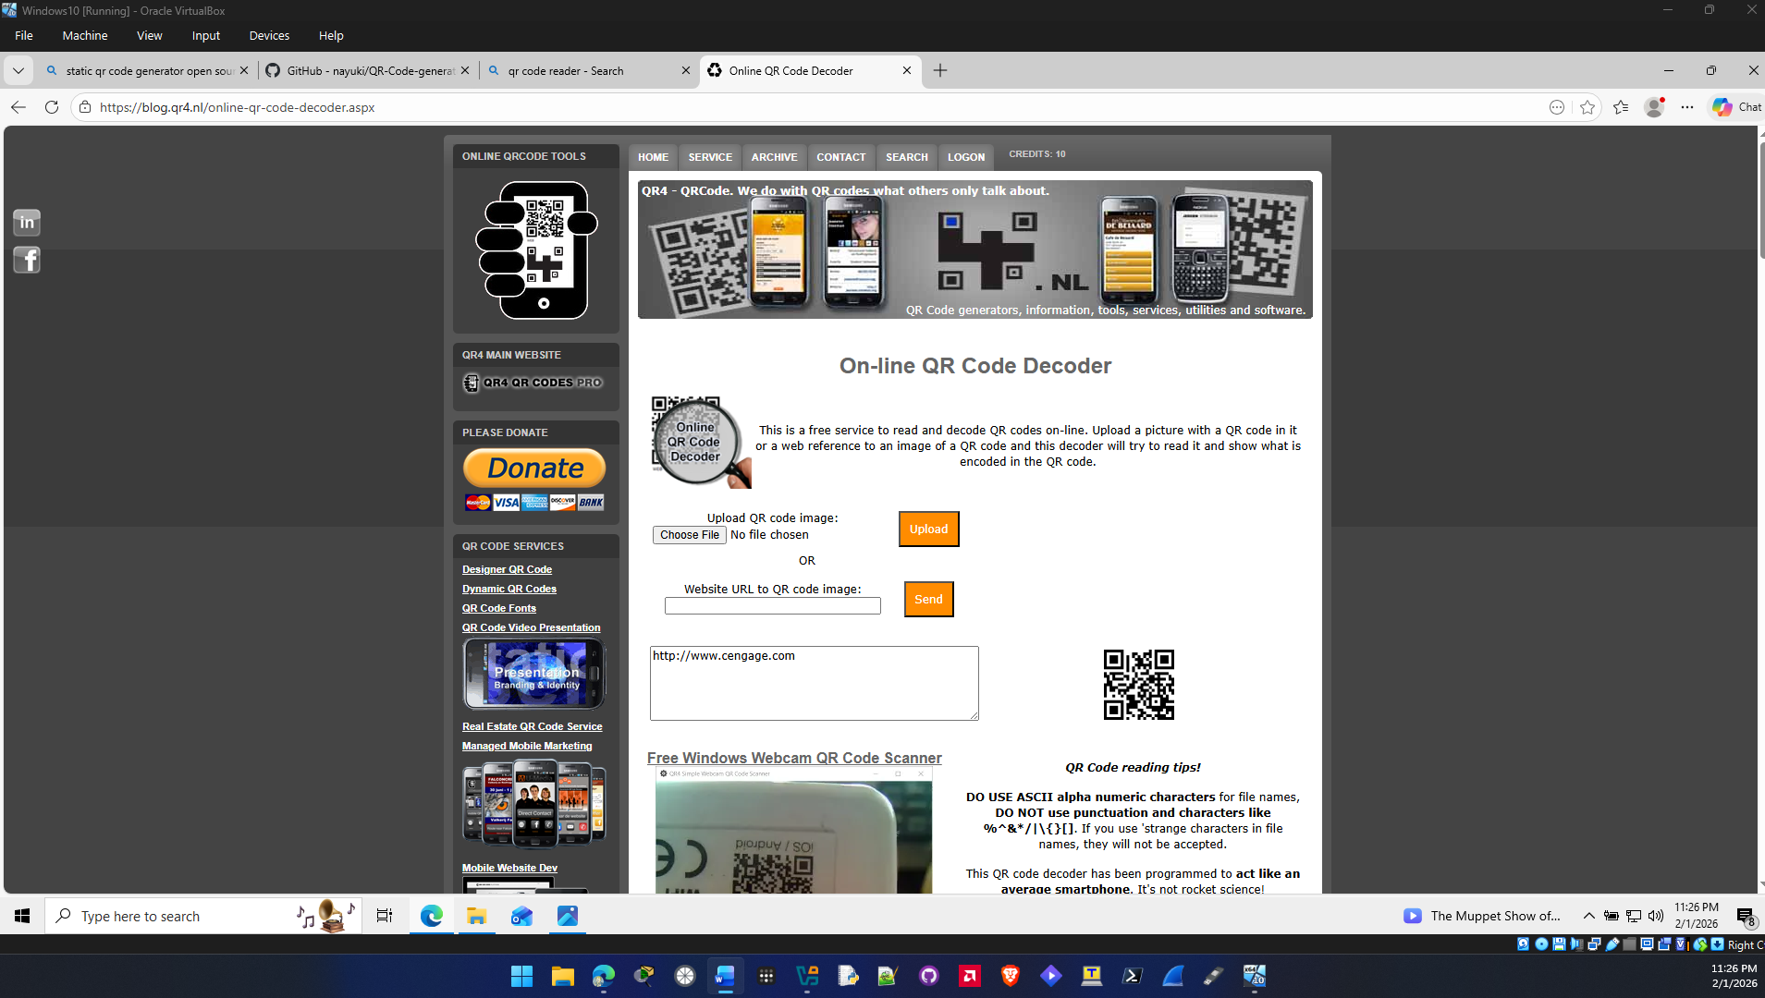
- Use your web browser to go to www.qrcode-monkey.com. (If you are no longer able to access the program through this URL, use a search engine to search for “QRcodemonkey”.)
- Click LOCATION.
- On the map, drag the pointer to an address with which you are familiar. Note how the Latitude and Longitude change.
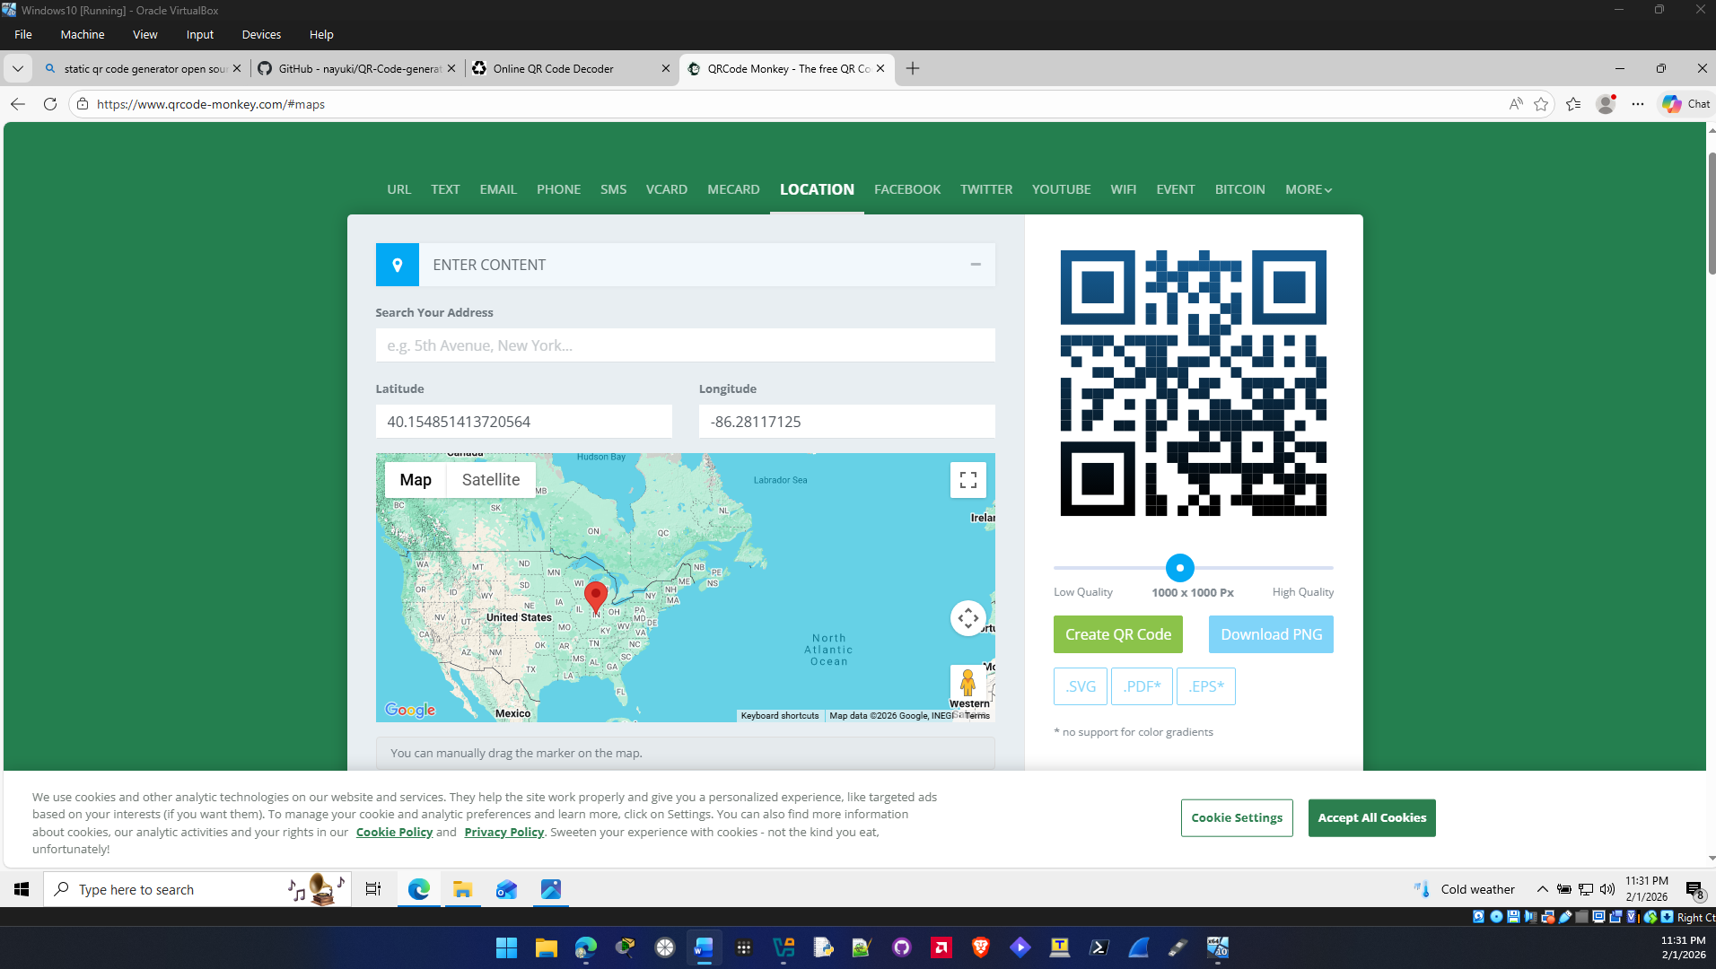

- Click Create QR Code.
- Click Download PNG and then click Save to download this QR code to your computer.
- Navigate to the location of the download and open the image. How does it look different from the previous QR code? Is there anything you can tell by looking at this code?
Yes it looks different and no there is nothing you can imediatlly tell other than the design is a little different.

- Use your web browser to return to blog.qr4.nl/Online-QR-Code-Decoder.aspx.
- Click Choose File.
- Navigate to the location of the map QR code that you downloaded on your computer and click Open.
- Click Upload.
- In the text box, a URL will be displayed. Paste this URL into a web browser.
- What does the browser display? How could an attacker use this for a malicious attack?
The browser display a google maps location with the latitude and longitude that I specified when I created the qr code. Attackers could use this to send incorrect addresses for shipping items or use it to stage a kidnap.
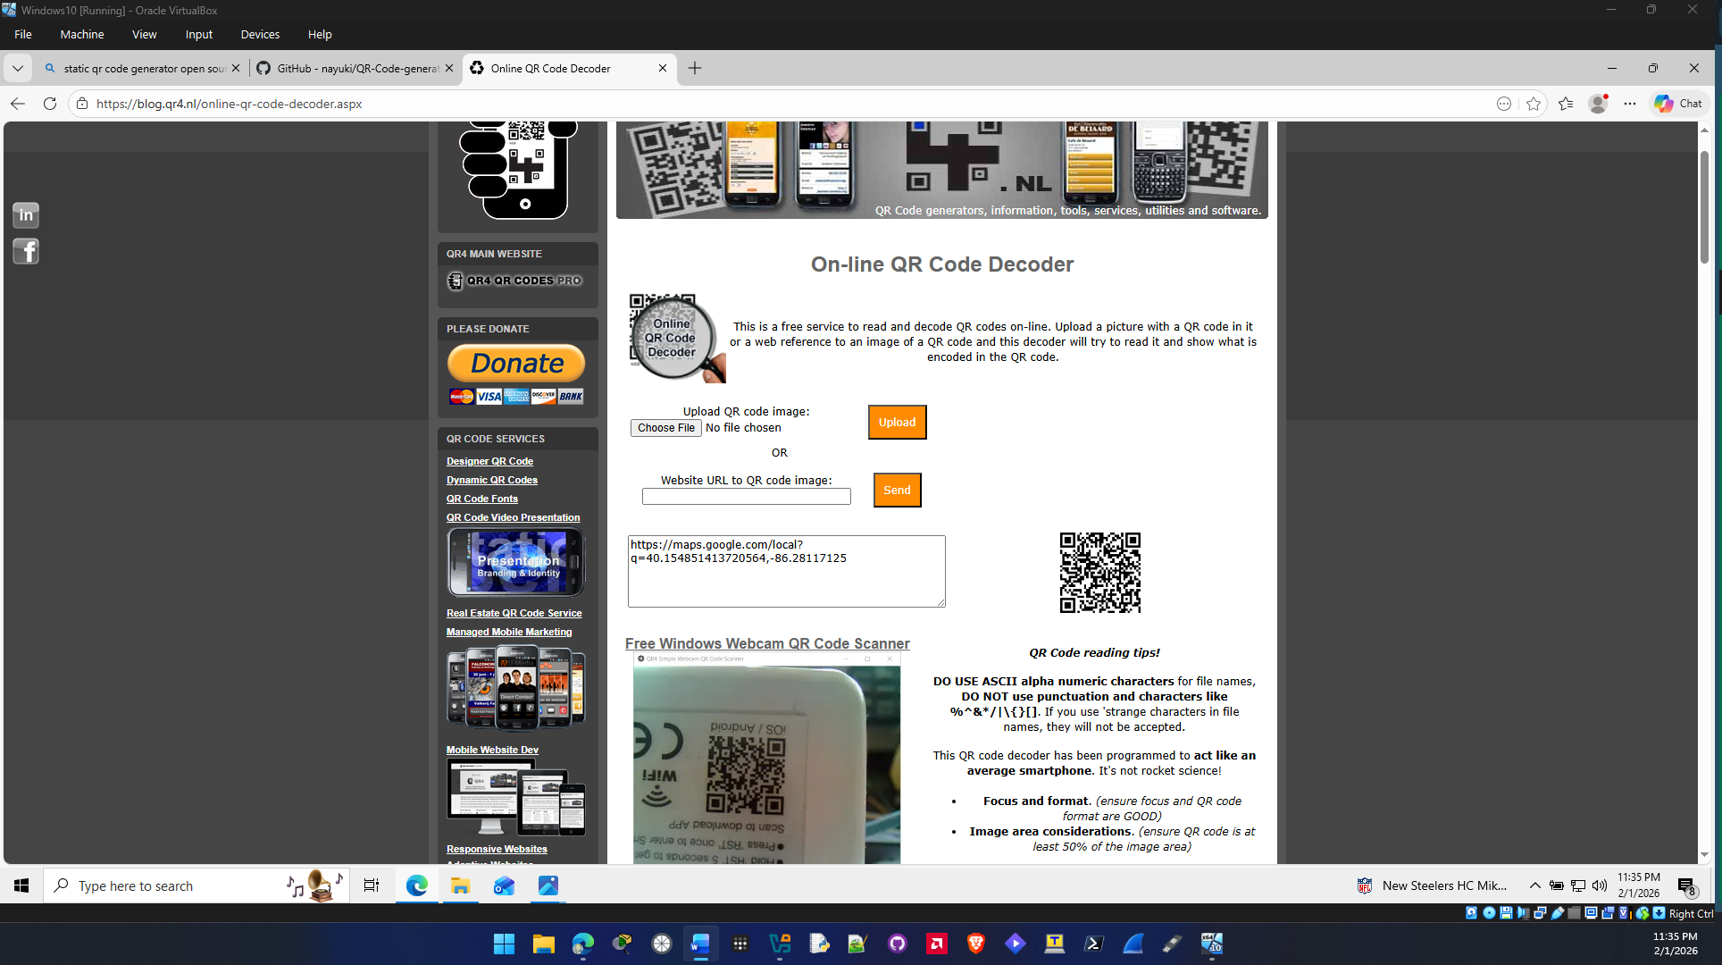

- Return to www.qrstuff.com.
- Click each option under DATA TYPE to view the different items that can be created by a QR code. Select three and indicate how they could be used by an attacker.
Wifi login: Attackers could include login credentials for a dummy network setup at a place that’s supposed to have a guest network then monitor all that traffic and steal information.

PayPal: Attackers could include a paypal address that is addresses to somewhere that look legit but it actually routes to their account.

File: Attackers could include a malicious file that automatically downloads and runs when you scan the qr code and infect your device with malware.

- Close all windows.

Criteria | Meets Requirements | Needs Improvement | Incomplete
Content | The assignment clearly and comprehensively addresses all questions in the assignment.  15 points | The assignment partially addresses some or all questions in the assignment.  8 points | The assignment does not address the questions in the assignment.  0 points
Organization and Clarity | The assignment presents ideas in a clear manner and with strong organizational structure. The assignment includes appropriate content, coverage of facts, arguments, and conclusions.  10 points | The assignment presents ideas in a mostly clear manner and with some organizational structure. The assignment includes appropriate content, coverage of facts, arguments, and conclusions.  7 points | The assignment does not present ideas in a clear manner or with a strong organizational structure. The assignment includes some appropriate content, but coverage of facts, arguments, and conclusions are not logically related and consistent.  0 points
Research | The assignment is based upon appropriate and adequate data collection and analysis of results from the activity or research from academically reliable sources.  5 points | The assignment is based upon adequate data collection and includes some analysis of results from the activity or research from academically reliable sources.  3 points | The assignment is not based upon appropriate data collection and includes no analysis of results from the activity or research from academically reliable sources.  0 points
Grammar and Spelling | The assignment has two or fewer grammatical and spelling errors.  5 points | The assignment has three to five grammatical and spelling errors.  3 points | The assignment has more than five grammatical and spelling errors, is incomplete, or is unintelligible.  0 points

